Femtoscopy and the shortest movie ever, presented in a PhD Dissertation

September 10, 2008.
The shortest film of Nature has been completed recently: it ends in 10⁻²⁴ seconds. This research was completed by a Hungarian PhD student, Tamás Novák, who prepared and defended his PhD thesis successfully at the renowned Radboud University of Nijmegen, The Netherlands.
Suggestion:
The shortest movie ever
(Slowed down to end in 2 seconds)

Femtoscopy

A micrometer is a millionth (10⁻⁶) of a meter, a nanometer is one thousandth of a micrometer or 10⁻⁹ meter, but a femtometer is a millionth of a nanometer, so 10⁻¹⁵ meter. Femtoscopy aims at the visualization of structures on the femtometer scale. Originally, microscopy and the nanoscopy were developed to answer fundamental questions on phenomena on the micrometer and on the nanometer scale. Up to now, the newly born femtoscopy is also entirely fundamental research, research that contributes to the further understanding of the laws of Nature on the femtometer scale. Practical applications of the results of fundamental research are found typically after further applied research and development. For example, microscopes were invented to visualize small objects like biological cells on length scale of micrometers, that are not visible to the naked eye. By now microscopes are integral part of medical practice.

A femtoscopic movie of particle production in electron-positron collisions was prepared and presented in the PhD thesis of Tamás Novák, who defended his thesis at the renowned Radboud University Nijmegen, The Netherlands on September 4, 2008. The data were taken by the L3 detector at the LEP accelerator, in high energy electron-positron collisions in the LEP accelerator in the European Laboratory for Nuclear Research CERN at Geneva, Switzerland, in 1994 (Since 1994, the both the LEP accelerator and the L3 detector were dismantled to make space for the LHC accelerator and the ALICE experiment. These new tools have just started their research operation recently, on September 10, 2008).
Electrons and positrons themselves have no size, are point-like or at least much smaller than a femtometer. In a high-energy collision of electrons and positrons, tens of elementary particles, in particular pions, are emitted in two or more jets. They are detected in particle detectors placed at the relatively large distance of centimeters or even meters from the collision point.

This particular data analysis with a new method was started by Tamás Novák in 2002. The problem for this thesis was, therefore, the measurement of the spatial size and shape of the emission region of the most abundantly produced particles (pions) close to the collision point itself, but also their time dependence, so the size and shape as a function of space and time, just like in a movie. Close to the collision point itself means at a distance of some femtometers (fm) or less, at times of some fm/c or less. A fm/c is the time required by light with its speed of c = 300.000 km/sec to pass through a distance of one fm, i.e., about 3 times 10⁻²⁴ seconds, or, three yoctaseconds.

To achieve measurements in the femtometer region, Novák made use of the so-called Bose-Einstein interference of identical pions. The method is borrowed from astrophysics, where Bose-Einstein interference of photons (elementary particles of light) is was discovered first and was utilized to measure the angular diameter (visible size) and also shape of main sequence stars. After about 50 years of additional research and development, we are now able to produce not only static images of particle production in elementary particle reactions, but these days we can measure the time evolution of this process and are able to create a movie or a video on the time evolution of particle production in these elementary particle reactions.

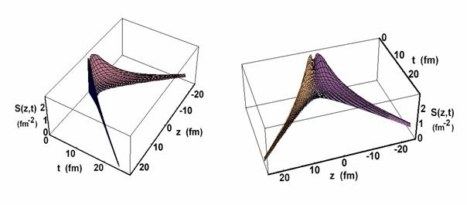

Fig. 1.
The precision of the results reached by Novák in four-dimensional space-time at such a small scale are no less than amazing. Fig. 1 shows a projection of the originally four-dimensional strength of pion emission onto the plane of z and ct, where the z-direction is the spatial direction of flight of the particle jet and t the time, and where the collision point lies at z=0 and t=0. The structure reminds us of a boomerang. The most abundant pion emission takes place at z and ct values of about 2 fm, but with tails of a length exceeding 20 fm in the direction of the diagonals in the zt plane, i.e., at z = ct and z = - ct, the so-called light cone. These are just those directions in the zt plane of a system or signal emitted from the collision point with the speed of light. At low as well as at high z and t values, the pion production takes place close to the light cone, at values of the so-called proper time τ of about 0.3 fm/c, so about 10⁻²⁴ seconds.

Particularly interesting is further the projection of the four-dimensional emission strength onto the plane orthogonal to the jet direction z, so in the xy plane. Fig. 2 shows the emission strength in this plane at a proper time of 0.3 fm/c (=10⁻²⁴ seconds). At that moment, a ring-shaped wave front has grown at the speed of light from originally zero to a radius of 0.3 fm. In analogy one could think of an expanding ring-shaped wave front originating from a stone thrown into a pond, but then in a femtometer world. An ultraslow-motion version of the shortest movie in the world can be viewed in the web under http://www.hef.ru.nl/~novakt/movie . The PhD dissertation of Tamás Novák with all details of the analysis is also freely available at http://www.hef.kun.nl/~novakt/phd/thesis_novak.pdf , and his summary of these results was presented at http://www.hef.kun.nl/~novakt/phd/defense_novak.ppt .

Pion emission makes us think of a water hose with a thick belly in the middle, a snake which is almost empty inside, which expands at almost the speed of light in the longitudinal (z) and transverse (x and y) directions, but which looses strength during that expansion.

The research of Dr. Novák was part of the research line of Dr. Metzger within the research institute of HEFIN (headed by Prof. E.W. Kittel), later IMAPP (headed by Prof. S.J. De Jong) of the Radboud University Nijmegen, Nijmegen, The Netherlands. As supervisors acted Prof. E. W. Kittel (Radboud University, Nijmegen) and Prof. T. Csörgő (MTA KFKI RMKI, Budapest), as co-supervisor Dr. W. Metzger (Radboud University, Nijmegen).

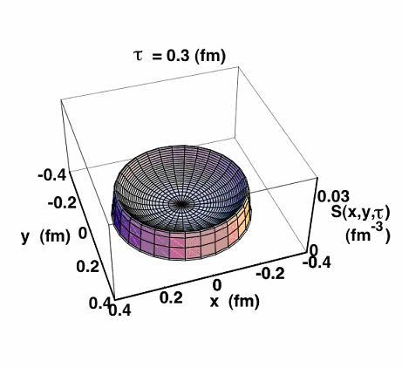

Fig. 2.

Interesting facts and Dutch - Hungarian collaboration:

It is unusual, that the results of a PhD thesis and a promotion to a doctor are followed by a press release at such a renowned insitute of higher education as the Radboud University of Nijmegen, Nijmegen, The Netherlands.

The English text above has been prepared based on the original press release in Dutch language, issued by the Institute for Mathematics, Astrophysics and Particle Physics (IMAPP) of the Radboud University, Nijmegen. A shortened version of this press release appeared on the web-page of the Radboud University at the time of the promotion, and the full text has been distributed to the press in the Netherlands by the press office of this Institution.

14 years passed after the data taking until the completion of the film. The preparation of this PhD dissertation lasted for 6 years, during which periond the candidate spent three years in The Netherlands, and the other half in Hungary, in a collaboration between the Radboud University of Nijmegen and the KFKI Research Institute for Particle and Nuclear Physics of the Hungarian Academy of Sciences.

In real time, this film lasts only for 10⁻²⁴ second, that has been slowed down to 2 seconds, so that we can see it: the original phenomena is way too fast to be observable by naked eye ...

If we slowed down, by the same factor, the Intercity train that commutes with an average speed of 80 km/h between Budapest and Vienna, then, during its 3 hours of its normal commuting time, this train would pass only three times one hundredthousandth of the diameter of the nucleus of a gold atom. Compared to this speed, the velocity of a moving snail is lightning fast. We may also compare the lenght of this film to the frequency of a few Gigahertz, which is a typical clock signal frequency in present day notebooks and computers. During such a single computer clock cycle, this film about elementary particle production could be played million times billion or 10¹⁵ times.

This press-release is based on the press release of the Radboud University of Nijmegen, Nijmegen, The Netherlands, in Dutch language, at
http://www.ru.nl/home/nieuws/algemeen_oznieuws/nieuw_femtoscopie_en/
http://www.ru.nl/onderzoek/instituten/overzicht/imapp/institute_for/

The English version of these press releases was prepared by Prof. E. W. Kittel and Prof. T. Csörgő, the supervisors of Dr. T. Novák's research.

